Welcome back to my blogging platform!

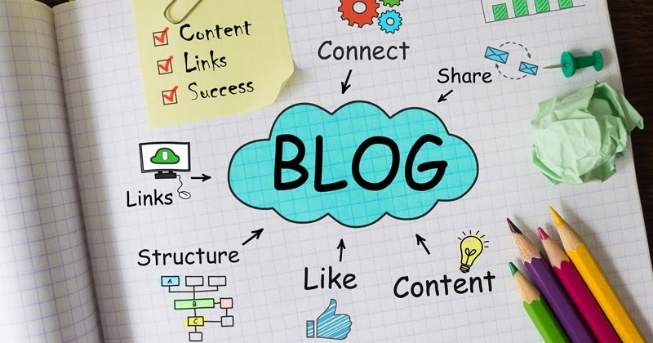

There's so much happening in the world today, and I can't wait to dive into it all with you. Join me on this exciting journey as I share my thoughts and insights on a variety of topics.

While the world is constantly evolving, I hope we can hold on to certain values like morals, empathy, and community spirit. Social media has its perks, but it has also brought about some negative trends that we need to address.

Through this platform, I aim to create a positive and vibrant community by discussing topics that matter to me and, hopefully, to you too. One of my favorite subjects is the numerous changes happening globally. Let's embark on this adventure together and explore the world around us.

Allie O’Connor

Allie O’Connor